Project: |  | Strangers at Depth (SAD)
Team No.: |  | Team 12
Class: |  | CSE 3310; Fall 2021
Module: |  | System Requirements Analysis (SRA)
Deliverable: |  | SRA Document
Version: |  | [1.0] | Date: | [10/28/2021]

Contributors:
Antonio Yep
Biraj G C
Gerald Kimeu
Samuel Terwilliger
Henry Tran

Revision History
Version number | Date | Originator | Reason for change | High level description of changes
1.0 | 10/28/2021 | Team 12 | Initial draft
2.0 | 12/6/2021 | Team 12 | Demo Revision | Revisions to reflect completion status at time of demo

TABLE OF CONTENTS
1. Introduction and Project Overview 1
2. Objectives 1
2.1 BUSINESS Objectives 1
2.2 SYSTEM Objectives 1
3. Project Context Diagram 1
4. Systems Requirements 1
4.1 “Registration and Login” Requirements 1
4.2 “Home Screen” Requirements 1
4.3 “Advertisement” Requirements 1
4.4 “Play” Requirements 1
4.5 “Battle Royale” Requirements 1
4.6 “Player” Requirements 1
4.7 “Profile” Requirements 1
4.8 “Leaderboards” Requirements 1
4.9 “Store” Requirements 1
4.10 “Termination” Requirements 1
5. Software Processes and Infrastructure 1
5.1 Hardware and Infrastructure 1
5.2 UML Diagrams 1
5.3 Screen Shots 1
5.4 Test Plan 1
6. Assumptions and Constraints 1
6.1 ASSUMPTIONS 1
6.2 CONSTRAINTS 1
6.3 Out of Scope material 1
7. Delivery and Schedule 1
8. Stakeholder Approval Form 1
Appendix: 1

1. Introduction and Project Overview

Design and develop a fun mobile Android 2-D multiplayer battle royale where players find treasure, gold coins called Krakens, hidden in the depths of the deep ocean while competing against other players online, but only one player’s loot will see the sunlight of day. The game will include the following features (note: these are subject to change based on Team 12’s group decision):

❖Registration Login: New users will need to sign up to create a new account with a username and password. Returning users must authenticate using their username and password to log in.

❖Home Screen: Users will be greeted with a main screen that includes appropriately themed project title, animated background, and different menu options that will allow the user to navigate the application.

❖Advertisements: Whenever the user is idle a closable pop-up advertisement will appear with the option to close out of the advertisement.

❖Play: Users will make and host a lobby for others to join.

❖Battle Royale: Players will load into the game, attack each other with weapons, collect gold coins called Krakens, avoid obstacles, and survive as the screen gradually scrolls up and eliminates players. There can only be one winner, if you are eliminated you will lose the Krakens you collected that game.

❖Player: Players have health and their number of collected Krakens. Players will also be able to dodge obstacles by moving.

❖Profile: Users can view their achievements and claim a daily reward of Krakens for logging in.

❖Leaderboards: View your rank compared to other players based on total Krakens, total wins, or number of skins collected.

❖Store: Use Krakens to purchase cosmetic accessories/skins.

❖Termination: While playing a game, players have an option to quit the game or continue playing.

2. Objectives

2.1 BUSINESS Objectives
The following is a list of business objectives:
Objective 1: Registration and Login: All members must register an account/login with username and password to access the system.

Objective 2: Home Screen: Users should be able to access various menu options through the home screen.

Objective 3: Advertisements: Pop up when the user is idle.

Objective 4: Play: Users can create and join a lobby of 1-4 players. User can start match with at least 2 players.

Objective 5: Battle Royale: The map should load when started and obstacles will randomly spawn as the screen gradually scrolls up.

Objective 6: Player: Avatars can be selected by players who have health points, collect game currency, jump, move, and use items.

Objective 7: Profile: Users can view their achievements and claim their daily rewards for logging in.

Objective 8: Leaderboards: Users can sort the leaderboards by wins or total game currency. The user can view their rank in the leaderboard.

Objective 9: Store: Users can choose a category listed in a menu to view that category’s items. User can purchase cosmetics with sufficient game currency.

Objective 10: Termination: System should be closed if user terminates the application in game.

2.2 SYSTEM Objectives
The following is a list of system objectives:

Objective 1: System will be an Android application

Objective 2: Unity will be used to develop the application and game systems

Objective 3: Firebase will be used to save limited amount of data

Objective 4: Photon Unity Network will be used as servers for multiplayer

3. Project Context Diagram

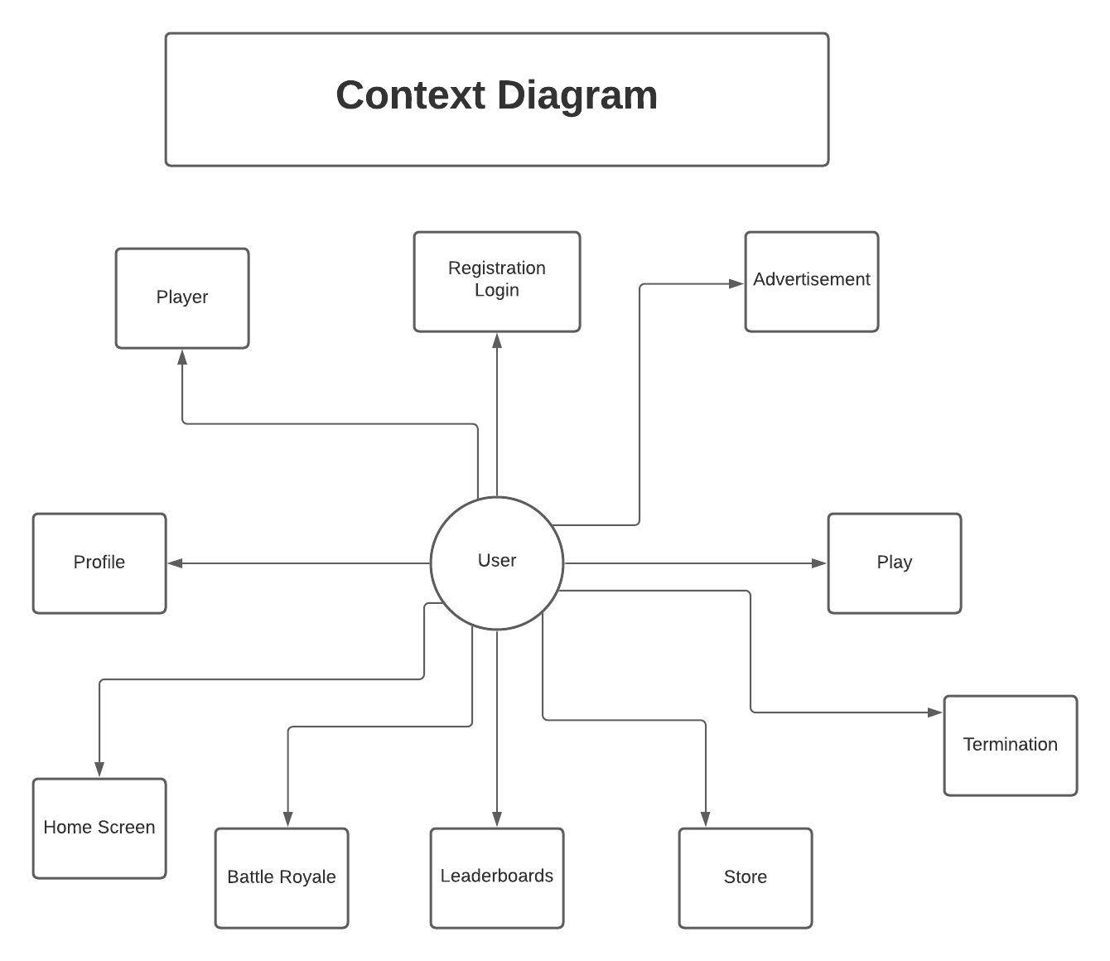

4. Systems Requirements

4.1 “Registration and Login” Requirements

Requirement Title: | Registration and Login
Sequence No: | 001
Short description: | Register a new user
Description: | New users must first register with the following items to gain access to the application:  - Username (3-8 characters, alphanumeric, wild characters not allowed)  - Password (6 characters minimum, must include at least one number)  - Confirm Password (same as password)  - Valid Email Address (used for resetting passwords)  User can press:  - Submit (register)  - Cancel (discard everything and return to “Are you a returning user?”)
Pre-Conditions: | Duplicate registration not allowed (username or email is taken or already in use)  Application must be loaded already  User is not a returning user with an already registered account
Post Conditions: | Generate user into the database with an ID# if registration successful  Send user to login screen if registration successful  Unsuccessful registration: error, reset, and try again
Other attributes: | None

Requirement Title: | Registration and Login
Sequence No: | 002
Short description: | Login returning user
Description: | Enter username and password, then submit to login.  User can press:  - Submit (login)  - Cancel (discard everything and return to “Are you a returning user?”))
Pre-Conditions: | User is a returning user who has already successfully registered an account into the database
Post Conditions: | Unsuccessful login: error, reset, and try again
Other attributes: | None

4.2 “Home Screen” Requirements

Requirement Title: | Home Screen
Sequence No: | 001
Short description: | Load home screen interface
Description: | Upon logging in or returning to home screen, users will be met with the home screen. The following will be displayed statically at the bottom of the screen:  - Profile button  - Play button  - Store button  - Leaderboard button  And the rest of the screen has:  - Background avatar and theme (animated)  - Title logo (static)  - Termination button
Pre-Conditions: | User must be logged into an account to access home screen
Post Conditions: | None
Other attributes: | None

Requirement Title: | Home Screen
Sequence No: | 002
Short description: | Enter profile
Description: | Pressing the profile button in the home screen will load the system into the profile interface.  The button will be in a row of buttons on the bottom of the screen with an icon pertaining to user profile.
Pre-Conditions: | None
Post Conditions: | The button will be lit up when pressed.
Other attributes: | None

Requirement Title: | Home Screen
Sequence No: | 003
Short description: | Enter play
Description: | Pressing the play button in the home screen will load the system into the play interface.  The button will be in a row of buttons on the bottom of the screen with an icon pertaining to “play”.
Pre-Conditions: | None
Post Conditions: | The button will be lit up when pressed.
Other attributes: | None

Requirement Title: | Home Screen
Sequence No: | 004
Short description: | Enter store
Description: | Pressing the store button in the home screen will load the system into the store interface.  The button will be in a row of buttons on the bottom of the screen with an icon pertaining to a store.
Pre-Conditions: | None
Post Conditions: | The button will be lit up when pressed.
Other attributes: | None

Requirement Title: | Home Screen
Sequence No: | 005
Short description: | Enter leaderboards
Description: | Pressing the leaderboards button in the home screen will load the system into the leaderboards interface.  The button will be in a row of buttons on the bottom of the screen with an icon pertaining to a leaderboard.
Pre-Conditions: | None
Post Conditions: | The button will be lit up when pressed.
Other attributes: | None

Requirement Title: | Home Screen
Sequence No: | 006
Short description: | Enter Termination
Description: | Pressing the termination button in the home screen will close the application.  The button will be on the top right of the screen with an icon pertaining to an exit.
Pre-Conditions: | None
Post Conditions: | The button will be lit up when pressed.
Other attributes: | Pop up with message “Are you sure you want to quit?” with a confirm or cancel button.

4.3 “Advertisement” Requirements

Requirement Title: | Advertisement
Sequence No: | 001
Short description: | Shows user a pop-up advertisement
Description: | A basic pop-up advertisement should appear on top of the user’s current screen:  - Button to close and exit the pop-up advertisement that returns the user to their previous screen  - Sponsor’s or advertiser’s name should be displayed with the advertisement
Pre-Conditions: | User must be inactive for 7 seconds  Application is open and loaded already
Post Conditions: | None
Other attributes: | None

4.4 “Play” Requirements

Requirement Title: | Play
Sequence No: | 001
Short description: | Enter Play
Description: | Upon Entering the Play from home screen, User has two options:  - Join an Existing Lobby  - Create New Lobby
Pre-Conditions: | None
Post Conditions: | None
Other attributes: | None

Requirement Title: | Play
Sequence No: | 002
Short description: | Create New Lobby
Description: | Upon Selecting Create New Lobby, User creates a new lobby which:  - Generates a public key that allows other players to join the lobby.  - Start the Game once the lobby has minimum number of players.  - Lobby must not exceed maximum number of players.  - Lobby can be cancelled.
Pre-Conditions: | None
Post Conditions: | The new lobby must exist for other players to join.
Other attributes: | Lists the username of all the people inside the game.

Requirement Title: | Play
Sequence No: | 003
Short description: | Cancel Lobby
Description: | Upon Selecting Cancel lobby:  - If there are remaining players in the lobby, one will inherit ownership of the lobby.  - If no players remain in the lobby, the lobby stops exiting and cannot be joined.
Pre-Conditions: | Lobby must be already created.  Users can only cancel the lobby that they have ownership of.
Post Conditions: | The user and all the other players go back into the play interface.  The generated pin will be invalid.  Lobby will be deleted from network.
Other attributes: | None

Requirement Title: | Play
Sequence No: | 004
Short description: | Join Existing Lobby
Description: | Upon Selecting Join Existing lobby:  - Player can join a lobby through lobby menu.  - Player can leave lobby before the game begins.
Pre-Conditions: | Lobby must exist for the player to join.
Post Conditions: | The lobby must be updated with players username and avatar.
Other attributes: | None

4.5 “Battle Royale” Requirements

Requirement Title: | Battle Royale
Sequence No: | 001
Short description: | Load and run game interface
Description: | Upon beginning a game, the following setup and maintenance should occur:  - Load the map  - Spawn platforms  - Spawn items  - Load players
Pre-Conditions: | A lobby of players must be ready to play
Post Conditions: | None
Other attributes: | None

Requirement Title: | Battle Royale
Sequence No: | 002
Short description: | Maintain the running game
Description: | While a game is in progress, the game system should be able to take action to facilitate the running of the game including:  - Spawning new platforms  - Spawning collectible gold coins called Krakens  - Scroll the screen upward
Pre-Conditions: | At least 2 players still have health.
Post Conditions: | None
Other attributes: | Game timer which tracks how long the game has been running.

Requirement Title: | Battle Royale
Sequence No: | 003
Short description: | End the current game
Description: | Once there is one player left, this indicates that the game is over, the game should terminate. The players should have the choice to return to the lobby or quit the game.
Pre-Conditions: | One player is left.
Post Conditions: | Give the players options to return to he lobby or to quit the game.
Other attributes: | None

4.6 “Player” Requirements
Requirement Title: | Player
Sequence No: | 001
Short description: | Player Action: Move
Description: | Player must be able to navigate through the game by moving a joystick displayed on the screen. Player can move in any direction inputted via the joystick.
Pre-Conditions: | Player is in the designated area within frame.  Player is not obstructed by terrain or other obstacles.
Post Conditions: | None
Other attributes: | None

Requirement Title: | Player
Sequence No: | 002
Short description: | Player Action: Use Items
Description: | Players must be able to activate their weapon by tapping a location on the screen which they would take aim at.
Pre-Conditions: | Player is allowed to fire.
Post Conditions: | Player weapon is placed on cooldown.
Other attributes: | None

Requirement Title: | Player
Sequence No: | 003
Short description: | Player Status
Description: | Player is shown number of current hit points. The hit points start at 200 at the beginning of each game. The hit points decrement as the player receives attacks from other players. Player is also shown Krakens held.
Pre-Conditions: | Player is in active game.
Post Conditions: | Increment and Decrement hit points.  Increment total number collected Krakens in current game.
Other attributes: | None

4.7 “Profile” Requirements

Requirement Title: | Profile
Sequence No: | 001
Short description: | Individualized user profile
Description: | Upon selecting to view their profile from the home screen, users will be met with their unique profile. The following will be displayed:  - Achievements button  - Daily Reward button  - Exit button
Pre-Conditions: | User must be logged in
Post Conditions: | Upon choosing to exit, the user must be returned to the home screen
Other attributes: | None

Requirement Title: | Profile
Sequence No: | 002
Short description: | Viewing achievements
Description: | Upon selecting Achievements from the profile menu, users will be met with their achievements. The following will be displayed:  - Achievements Completed  - Exit button
Pre-Conditions: | User has selected Achievements from the profile menu
Post Conditions: | Upon choosing to exit, the player must be returned to the profile menu.
Other attributes: | None

Requirement Title: | Profile
Sequence No: | 003
Short description: | Claim daily rewards
Description: | Upon selecting Daily Rewards from the profile menu, users will be met with the rewards for playing that day. The following will be displayed:  - Claim Rewards button
Pre-Conditions: | User has selected Daily Rewards from the profile menu
Post Conditions: | The claim-status of the daily reward and the player’s number of Krakens must be updated to reflect the rewards for that day
Other attributes: | None

4.8 “Leaderboards” Requirements

Requirement Title: | Leaderboard Screen
Sequence No: | 001
Short description: | Enter the Leaderboard interface
Description: | Upon entering the leaderboard from the home screen or profile, users will be met with the leaderboard. The following will be displayed:  - Sort by wins button  - Sort by rakens button  - Exit button
Pre-Conditions: | User must be logged in
Post Conditions: | None
Other attributes: | None

Requirement Title: | Leaderboard Screen
Sequence No: | 002
Short description: | Sort by total wins
Description: | Upon selecting to sort the leaderboard standing in order of total wins, the users displayed on the leaderboard should be ordered by most wins
Pre-Conditions: | User has selected the button to sort by total wins
Post Conditions: | Leaderboard display is updated to reflect user selected sort
Other attributes: | None

Requirement Title: | Leaderboard Screen
Sequence No: | 003
Short description: | Sort by total Krakens
Description: | Upon selecting to sort the leaderboard standing in order of total Krakens, the users displayed on the leaderboard should be ordered by most Krakens
Pre-Conditions: | User has selected the button to sort by total Krakens
Post Conditions: | Leaderboard display is updated to reflect user selected sort
Other attributes: | None

Requirement Title: | Leaderboard Screen
Sequence No: | 004
Short description: | Exit the Leaderboard interface
Description: | Upon exiting the leaderboard using the terminate button, users will be redirected to the home screen.
Pre-Conditions: | User has selected to exit the leaderboard
Post Conditions: | User is directed to home screen
Other attributes: | None

4.9 “Store” Requirements

Requirement Title: | Store
Sequence No: | 001
Short description: | Load store interface
Description: | Upon entering the store, a list of item categories will be displayed as a top-down menu. That categories’ items will be displayed in the main center screen. The top right will display the number of Krakens held.
Pre-Conditions: | If there are no more items available in that category, the store interface will display the message “Please check back later for more items!”.
Post Conditions: | None
Other attributes: | None

Requirement Title: | Store
Sequence No: | 002
Short description: | Category selection of items
Description: | Upon entering the store, a menu list will be shown on the left-hand side of the screen with different categories of cosmetics such as:  - Hats  - Character themes  - Item skins  However, due to time constraints, character skins are currently the only available category.
Pre-Conditions: | If there are no more items available in that category, the store interface will display the message “Please check back later for more items!”.
Post Conditions: | None
Other attributes: | By default, the first selection will be shown and the items in that category will be loaded and displayed onto the store interface when first accessing the store.

Requirement Title: | Store
Sequence No: | 003
Short description: | Store item display
Description: | The items will be displayed in a row going left to right. An arrow button will be available to click if the user wants to see more items of that category if available.
Pre-Conditions: | If there are no more items available in that category, the store interface will display the message “Please check back later for more items!”.
Post Conditions: | None
Other attributes: | After entering the store, the first category will be chosen by default and the items in that category will be loaded and displayed on the store interface.

Requirement Title: | Store
Sequence No: | 004
Short description: | Purchase Item Interface
Description: | When the user clicks on an item, a purchase interface pops up with the purchase button, an “x” button, and a preview of the item and price.  The “x” button would go back to the store interface if pressed.
Pre-Conditions: | There must be items available to purchase
Post Conditions: | None
Other attributes: | None

Requirement Title: | Store
Sequence No: | 005
Short description: | Purchase Item
Description: | If the user clicks the purchase button in the purchase interface, the system will check for sufficient Krakens compared to the item’s price.
Pre-Conditions: | None
Post Conditions: | If the number of Krakens is less than the item’s price, go back to the purchase item interface without unlocking that item for the player.  The item will be owned and show up in user’s customization options upon successful purchase.  The user’s Krakens should be deducted after successful purchase.  The item will be removed from the store display upon successful purchase.
Other attributes: | None

4.10 “Termination” Requirements

Requirement Title: | Termination
Sequence No: | 001
Short description: | Quit Application
Description: | Once the win condition has been reached the player will have an option to quit the game. A player can also exit out the game at any time by closing application.  Player can press:  - Quit application
Pre-Conditions: | Player is in a current game  Player presses quit game.  Player reaches win condition or loses game.
Post Conditions: | Application exits
Other attributes: | None

Requirement Title: | Termination
Sequence No: | 002
Short description: | Continue playing
Description: | Player that presses quit game is prompted with option to continue playing. Once player presses on continue playing the are brought back to current game state.  - Display “Resume” button on quit game dialog box
Pre-Conditions: | Player presses quit game
Post Conditions: | Application goes back to the current game
Other attributes: | None

5. Software Processes and Infrastructure

5.1 Hardware and Infrastructure
Android KitKat version is used. Firebase is used. Unity v2021.1.25 is used. Photon Unity Networking is used.

5.2 UML Diagrams
UML-Class-Diagram-System
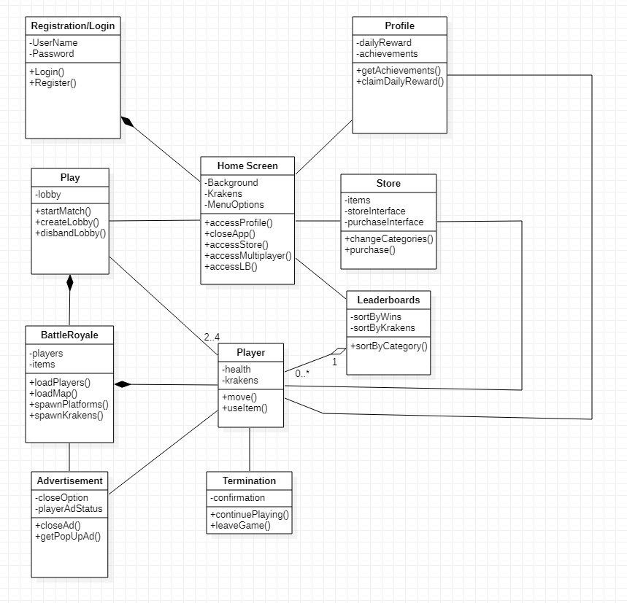
UML-STD-Registration Login
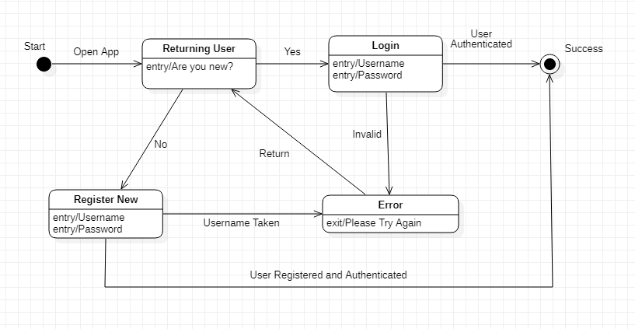
UML-Activity Diagram-Home Screen
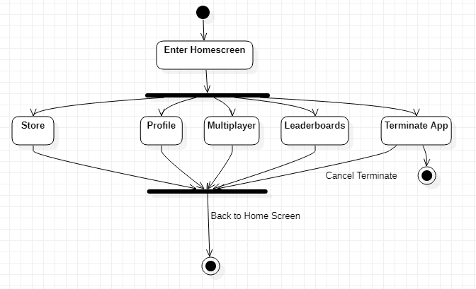

UML-STD-Advertisement
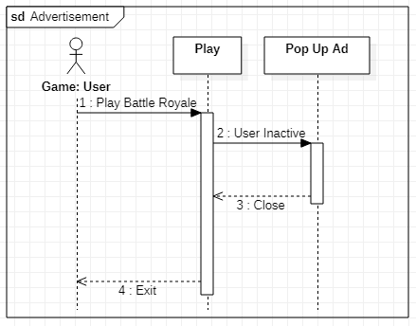
UML-STD-Play
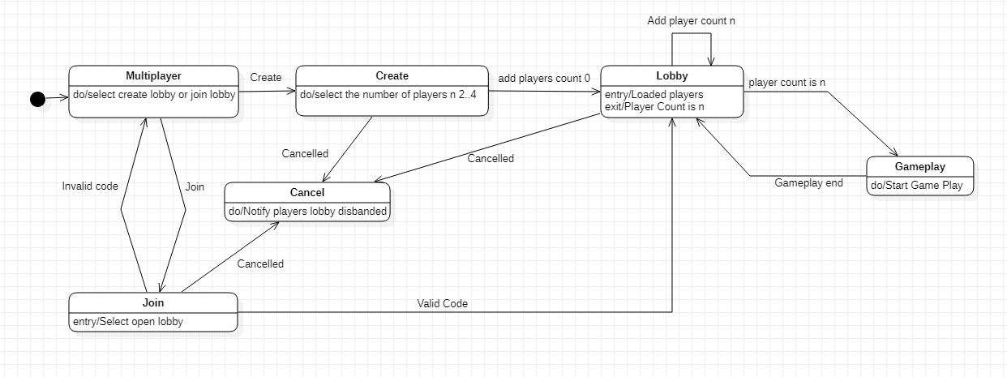

UML-STD-Battle Royale
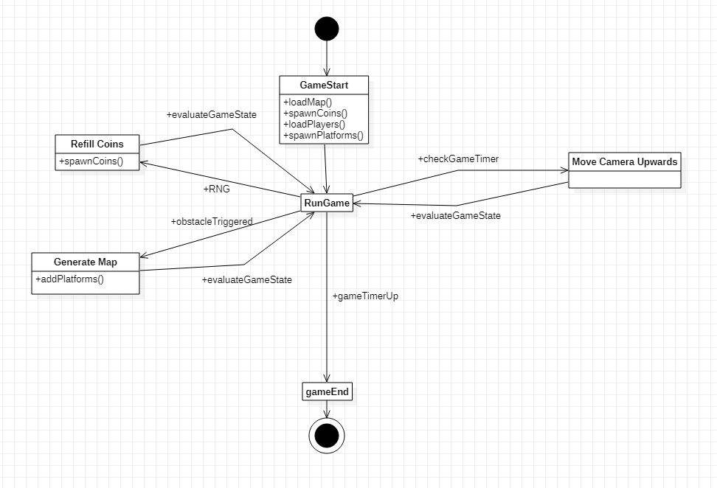
UML-STD-Player
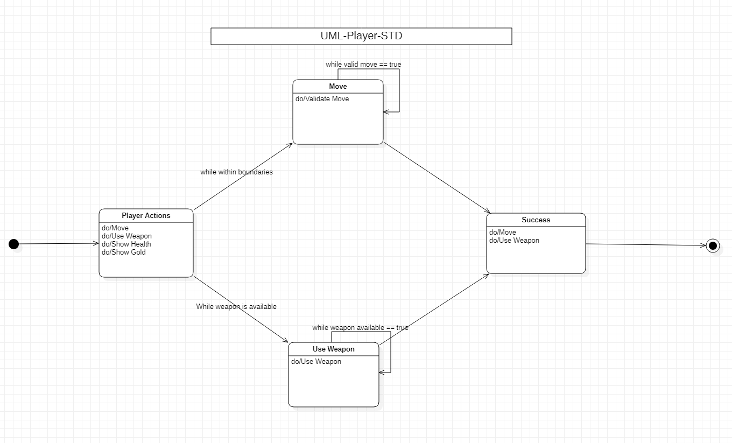

UML-Class-Diagram-Profile

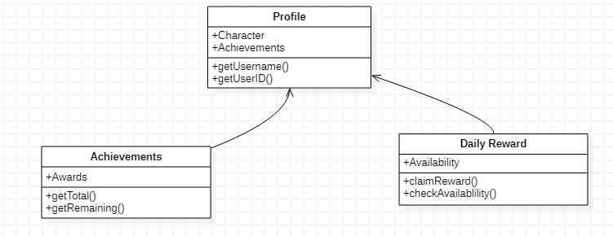

UML-Activity-Diagram-Leaderboards
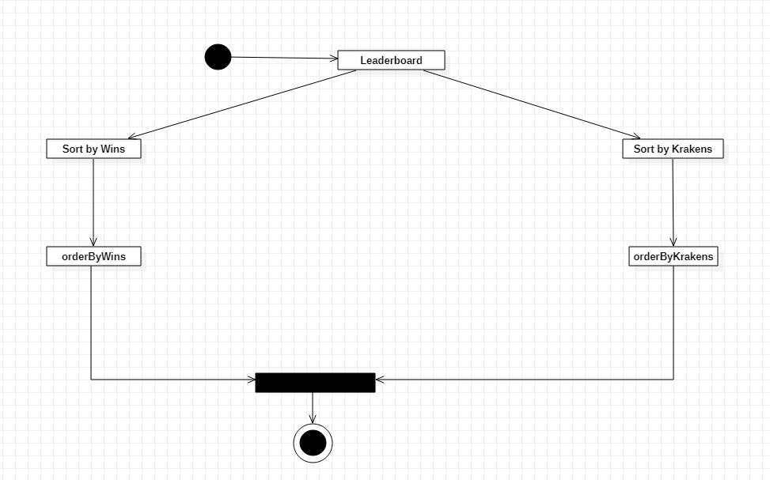

UML-Sequence-Diagram-Store
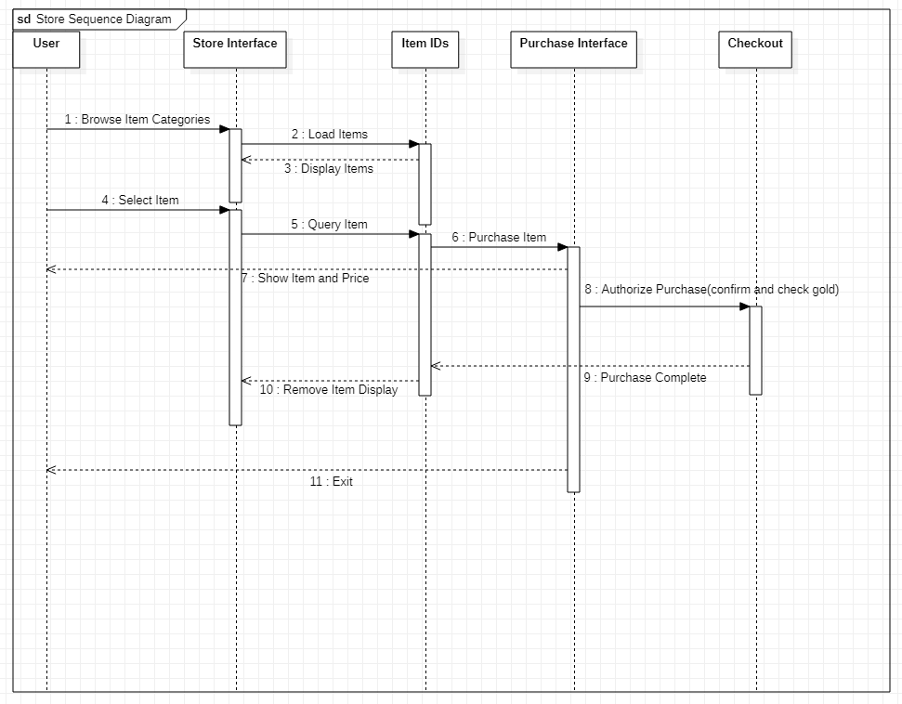

UML-STD-Termination
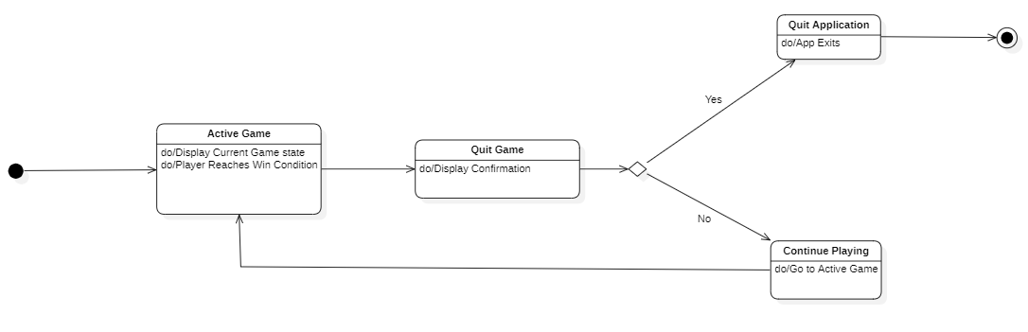

5.3 Screen Shots
Refer to User Manuel

5.4 Test Plan
Refer to Test Plan

6. Assumptions and Constraints

6.1 ASSUMPTIONS
The following is a list of assumptions:
- Ignore compliance issues
- The game will be family-friendly
- Advertisements are contracted already
- The system can run on the specified platforms

6.2 CONSTRAINTS
The following is a list of constraints:
- Team lacks android experience
- Team lacks game developing experience
- Schedule very aggressive
- Team lacks asset library
- Team lacks database experience
- File size constraints for free version control

6.3 Out of Scope material
The following is a list of “out of scope” material:
- Post Project maintenance is not covered
- Implement payment options for revenue
- Increase player count per lobby
- Introduce matchmaking to queue into a lobby
- Introduce cross-platform support
- Implement controller support
- Add more themed maps
- Add more various avatars
- Add a campaign mode
- Add featured game mode with different rule set
- Friends list
- Rank players into divisions

7. Delivery and Schedule

Task/Milestone Description | Anticipated Start Date | Anticipated End Date | Status | Comments
Prepare Requirements and UML diagram | 9/14/2021 | 9/30/2021 | Complete | Deliverable UML document. Increment 1 Deliverable
SRA document (Includes project objectives, Requirements and UML diagrams) | 10/5/2021 | 10/28/2021 | Complete | Deliverable will be the SRA document. All stakeholders agree on the content of the SRA by signing in section 8.  Increment 2 Deliverable
Login and registration design and implementation | 11/28/2021 | 12/6/2021 | Complete | Henry Tran is responsible
Home screen design and implementation | 11/28/2021 | 12/6/2021 | Complete | Antonio Yep is responsible
Profile design and implementation | 11/28/2021 | 12/6/2021 | Complete | Samuel Terwilliger is responsible
Leaderboards design and implementation | 11/28/2021 | 12/6/2021 | Complete | Samuel Terwilliger is responsible
Store design and implementation | 11/28/2021 | 12/6/2021 | Complete | Antonio Yep is responsible
Play design and implementation | 11/25/2021 | 12/6/2021 | Complete | Biraj G C is responsible
Player design and implementation | 11/28/2021 | 12/6/2021 | Complete | Gerald Kimeu is responsible
Battle royale design and implementation | 10/28/2021 | 11/28/2021 | Complete | Antonio Yep, Biraj G C, Gerald Kimeu, Samuel Terwilliger, Henry Tran are responsible
Termination design and implementation | 11/28/2021 | 12/6/2021 | Complete | Gerald Kimeu is responsible
Advertisement implementation | 11/28/2021 | 12/6/2021 | Complete | Henry Tran is responsible
Test case design | 10/29/2021 | 11/18/2021 | Complete | Increment 3 Deliverable
External Documentation (i.e. User Manual) | 12/5/2021 | 12/7/2021 | Complete
Project presentation | 11/30/2021 | 12/7/2021 | Complete
Final Milestone: project delivery | 12/6/2021 | 12/7/2021 | Complete | Increment 4 Deliverable

8. Stakeholder Approval Form

Stakeholder Name | Stakeholder Role | Stakeholder Comments | Stakeholder Approval Signature and Date
Bahram Khalili | Development Mgr
Akshit Singhal | Project Assistant
Antonio Yep | Developer
Biraj G C | Developer
Gerald Kimeu | Developer
Samuel Terwilliger | Developer
Henry Tran | Developer

Appendix:

Basic Icons by Art By Kandles (used for visual assets)
Free Pixel Space Platform Pack by Aiden Art (used for visual assets)
Joystick Pack by Fenerax Studios (used for joystick controls)
Simple Heart Health System by Oarielg (used for visual assets)
Simple UI & icons by madder (used for interactive button visuals)
UnderWater Diving by Ansimuz (used for player animations and visual assets)

